Team ID : PNT2022TMID40633

**INSTRUCTIONS**

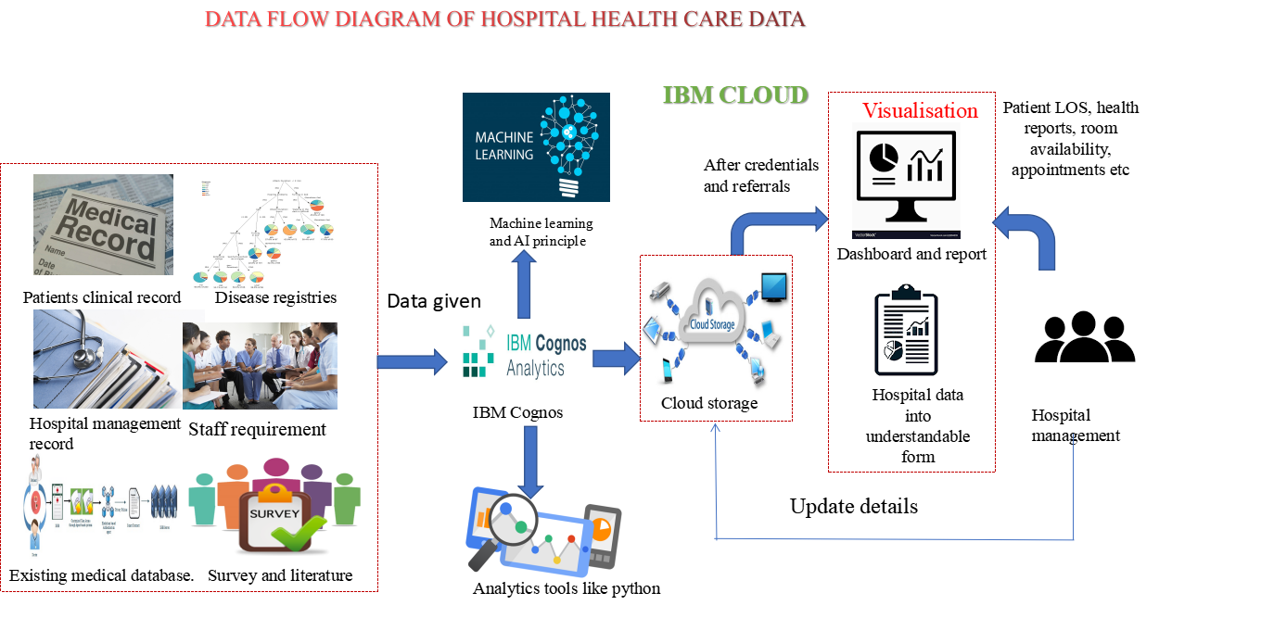

Define the process you want to visualize, or use a pre-existing one

Develop the data flow by using the shapes and connectors in the key

Adjust and fine tune the data flow

Review the data flow

Next Steps

Data

Data Collecting

***VISUAL KEY***

You can also make your diagrams more engaging by using images and icons!

Data

Process

External entity

Add your own!

***FLOW KEY***

This small rectangle is used for data that is required frequently or is produced in the process.

This shape is used for actions or instructions, the things that must be done.

It is where data comes from or goes to. It is external to the process.

Connects elements of the flow.

**NEXT STEPS**

**BRAINSTORMING AREA**

**MURAL TEMPLATE**

**Visualize data flows and behaviors to explain complex processes**

**Data Flow Diagram**

a template brought to you by your friends at MURAL

**Add labels to connectors** double click on the line or choose the “+T” symbol from the connector’s toolbar, then type your text.







Cleaned matrix

Continous value ?

Yes

Data Preprocessing

Data Normlalisation

Feature Selection

# Training D

Model Test and Training

Trained Model

Data Splitting

ata

LOS targeted

Predicted LOS

Data integrity